FIRST WORLD WAR MEMORIALS IN JESMOND

Summary
In 2014-15 I was able to locate ten more or less publicly accessible commemorative memorials in Jesmond. All honour local men who lost their lives in the Great War. Seven of the memorials are in churches, one in a local school, one in a cemetery and one in a sports pavilion.

The total number of service personnel honoured in these ten locations is 265, all of whom were men. Detailed information is given below. Of these 265 the names of 29 appear on two memorials and the names of another four: Matthew Lennox, Sid Smallwood, Andrew Smith and GP Woodall appear three times. These duplicated names are highlighted in yellow.

In a very small number of cases assumptions have had to be made eg that Ernest A Monkhouse (St George’s) is the same person as Alf Monkhouse (West Jesmond School), or that Albert Errington (St George’s and West Jesmond Primary School) is not the same as B Errington named on the plaque in St Hilda’s. In all 228 individuals are commemorated.

Additional information has been included about a small number whose names are in bold type. I have done so to move beyond the fixities of name and rank and to provide some personal and service details which puts some human flesh on the bare bones of basic identifying information.

A huge amount of information, including brief biographical details of many of the fallen, has been collected on the excellent North East War Memorials Project website. http://www.newmp.org.uk/search_results.php

Ten local memorials plus the memorial at the Royal Grammar School are covered alphabetically below in the main body of the report.

Enquiries were also made with other local institutions and locations as follows:

Church of the Holy Name This Roman Catholic church was opened in North Jesmond Avenue in 1929. An “iron church” on St George’s Terrace had provided a place of worship for Roman Catholics from 1903. Enquiries have confirmed there was no war memorial from the 1914-18 war.

Jesmond Old Cemetery There are ten First World War graves in what was then a private cemetery. These include a headstone with circled cross in memory of the brothers Hugh Vaughan Charlton of Cullercoats and John Macfarlane Charlton who were the sons and only children of the North East painter John Charlton RA and his wife Kate. There is no official memorial in the cemetery and it is not possible to say if any of those interred here were from Jesmond.

Jesmond Real Tennis Club was opened on Matthew Bank in 1894. It remained in the private hands of the Noble family until the early 1930s. Only then did it become a public club. There is no First World War memorial.

Jesmond Tennis Club This club had moved to its location just to the east of Osborne Road in 1890 but has no plaque from the First World War.

Masonic Lodge This is in Fern Avenue, Jesmond. I have been unable to make contact with members of this Lodge or to gain access to the premises. Alan Morgan’s book on Jesmond (From Mines to Mansions) states that the Masonic Lodge has met here only since 1923. Information on the internet indicates that the Hotspur Lodge is now based here. It dates from 1876 and was originally based in Lovaine Hall, which I think was on Lovaine Place, now the site of the Civic Centre. Grainger Lodge seems also to meet here but they were not formed until 1952.

Northumberland Tennis Club This club in North Jesmond Avenue was founded in 1926. Prior to that the site was a cricket ground owned by the Mitchell family of Jesmond Towers.

Royal Grammar School The school is referred to below but there is no easy means of distinguishing Jesmond residents who are in any event likely to be in a small minority. The memorial is accessible only with special permission.

Jesmond Synagogue was on Eskdale Terrace between 1915 and 1986 before transferring to Gosforth. A memorial service was held and a stained glass window were unveiled in memory of three members of the congregation who had lost their lives in the war. Sadly this proved premature as the deaths of three more of their members was notified in the closing months of the war. There were a further 28 names on a Roll of Honour detailing those who returned from the conflict.

By 1914 Jesmond was a well-established residential suburb of Newcastle, with a mix of mainly terraced housing in addition to a small number of larger detached properties to the east of Osborne Road. There was no concentrated employment in Jesmond at the time; no factories or offices such as existed in the town centre and on Quayside. It may be therefore that there was no workplace in Jesmond that had a plaque or memorial to honour employees who had given their lives. However there were three institutions on Tankerville Terrace which might conceivably have marked the losses of the Great War, but my enquiries with them have not borne fruit. They are

- The Northern Counties School for the Deaf founded in 1861 and now part of the Percy Hedley Foundation.
- The Princess Mary Maternity Hospital, which moved to Jesmond only in 1939. The hospital closed 1993 and was converted to high quality apartments. Prior to that the site had been since 1869 the Northern Counties Orphanage.
- The Fleming Memorial Hospital, founded in 1888 but relocated to the RVI in 1987. The site is now the Fleming Business Centre. I am informed that there was a memorial plaque at the Fleming Hospital which was removed to the RVI. I have made enquiries with the RVI but so far no-one has been able to shed any light on the fate of the original plaque.

It is possible that 1914-18 plaques exist elsewhere in Jesmond, but I have not come across them, nor been made aware of them.

It should also be emphasised that there will be other young men of Jesmond who gave their lives in the First World War and who have either not been officially commemorated at all, or where their names are recorded, they are on memorials outside of Jesmond itself eg in Sandyford. The whereabouts of some plaques eg from the Baptist Church (now Haldane Court on Osborne Road) and the Wesleyan Methodist Church (now Pilgrims Court on Eslington Terrace), are not known, but if they exist at all they seem no longer to be in Jesmond.

JESMOND’S FIRST WORLD WAR MEMORIALS

Holy Trinity
The origins of this church date from 1905 when the chancel area, together with the organ chamber, vestry and side chapel, were consecrated as Holy Trinity Church. They were designed by Hicks and Charlewood. There was a temporary addition of an iron nave for seating the congregation (the 'Tin Tabernacle').

The foundation stone for a permanent nave and tower was laid in October 1920 by Mrs William John Sanderson whose sons Philip Noel Sanderson and Geoffrey Euan Sanderson lost their lives in the Great War. There is a stone inside the church with their names engraved and their names appear in Jesmond Parish Church. Their home was Eastfield Hall, Warkworth and they are commemorated by two plaques in their local parish church of St Lawrence.

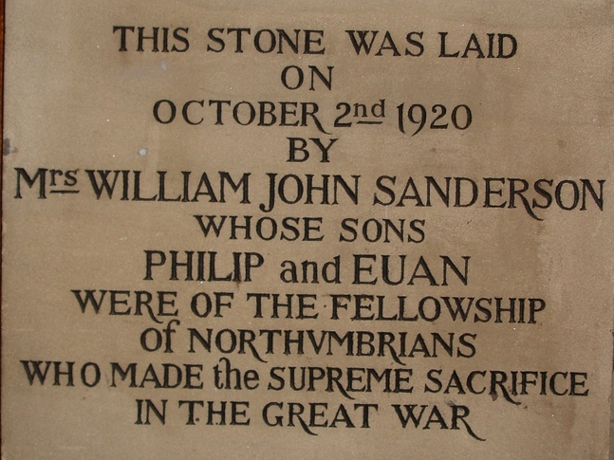

Two years later the church building recognisable today was completed. On 24th September 1922 the Bishop of Newcastle consecrated and dedicated the 'War Memorial Church of the Holy Trinity' witnessed by various naval and military personnel, including a guard of honour formed by the crew of a battleship moored on the River Tyne especially for the occasion.

The completed church was the gift of a ship owning family, Robert and Anne Dalgliesh, as a personal thanksgiving that none of their family had died during the Great War and “as a memorial to those of Northumberland and Tyneside who fell in the War”. A brass plaque dated 1922 and donated by RS Dalgliesh is dedicated to those who fought in WW1.

NB there is a scale model replica of a cargo steamer with sits atop the spire as a weather vane. It commemorates those who lost their lives in the merchant marine.

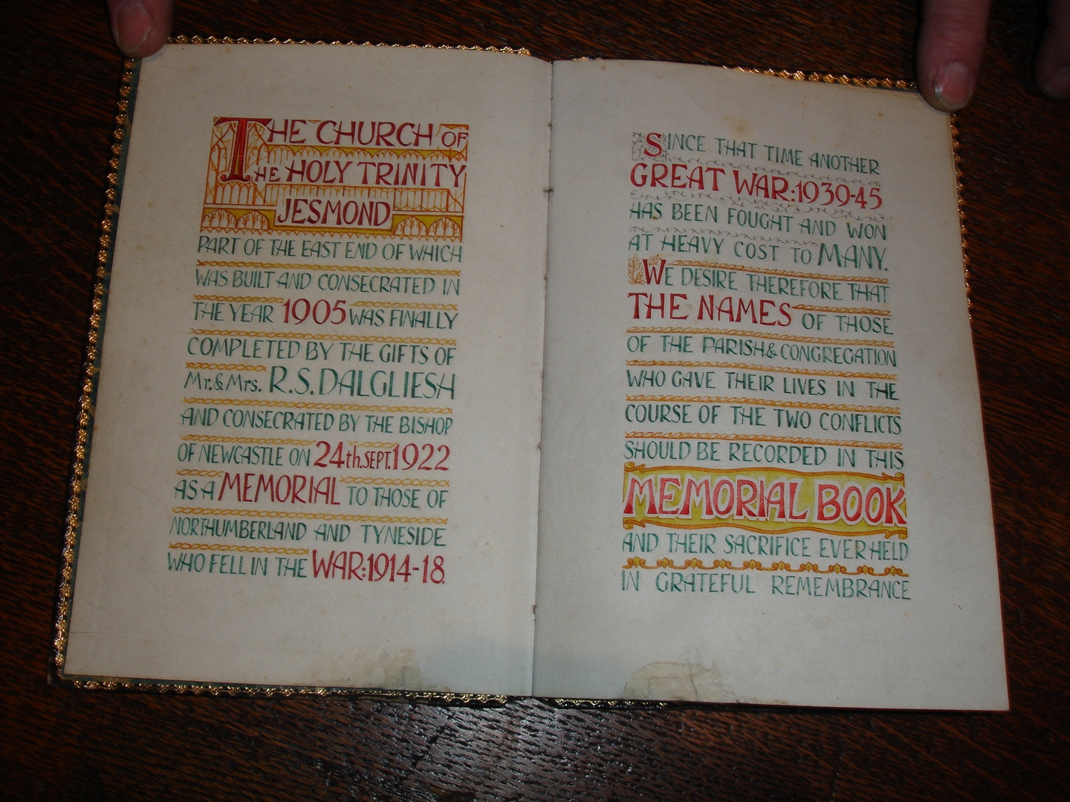

The fascinating set of stained glass windows were installed together and are thematic. They were designed by the local Nicholson studios. Many are dedicated to sections of the armed forces and in memory of local regiments and battalions. The badge of each of these services is placed below the picture thus identifying the window with its special corps. Some of the windows also show a biblical image linked to the regiment or service depicted (eg the Parable of the Good Samaritan on the RAMC window). The window dedicated to St Nicholas (Patron Saint of Sailors and Boys) has a panel showing a picture of HMS Lance (Capt de Wion Egerton DSO) which fired the first shot of the war, sinking a German minelayer outside Harwich.

Other windows are dedicated to the Royal Engineers, the RASC, the “loyal” (royal?) Regt of Artillery, the Royal Naval Air Service, the RFC, the Fleet Auxiliary Service, the Northumberland Fusiliers, the DLI, the Royal Navy, the RAMC and the British Red Cross, the Mercantile Marine, the Northumberland Hussars, the WRNS and the Queen Mary’s Army Auxiliary Service.

A Book of Remembrance with its beautiful calligraphy gives details of four parishioners who lost their lives:
RUPERT VICTOR BULMER Sapper, Royal Engineers, died 6th November 1918
ALBERT EDWARD LOWES Driver, Royal Army Service Corps (TA) died April 26th 1915
WILLIAM ROWLAND Trooper, Northumberland Hussars died March 4th 1915
HARRY FORBES SEED Lt. Northumberland fusiliers, died Sept 23rd 1917

Jesmond (the former Northumberland County) Cricket Club
Has matching commemorative wooden plaques for club members who fell in both world wars. These were donated by Sir Ralph George Elphinstone Mortimer (1869-1955) who was a leading batsman for the club and had a distinguished local career (reference in Wikipedia). He pledged £250 towards the purchase of the cricket ground in 1897. He lost a brother in WW1 (qv below) and his only son in WW2. He died at Milbourne Hall nr Ponteland. There was an article about him in the Evening Chronicle 19.07.2014.

The Great War plaque has a dark oak frame with fluted pillars and with a light oak panel. It is surmounted by the badge of the Northumberland Fusiliers. A Maltese Cross is at the top left and a raised and gilded eagle at top right with the letters RAF incised above. It was completed and unveiled in April 1920. The sculptor was Frederick Atkinson of Atkinson Bros of Newcastle.

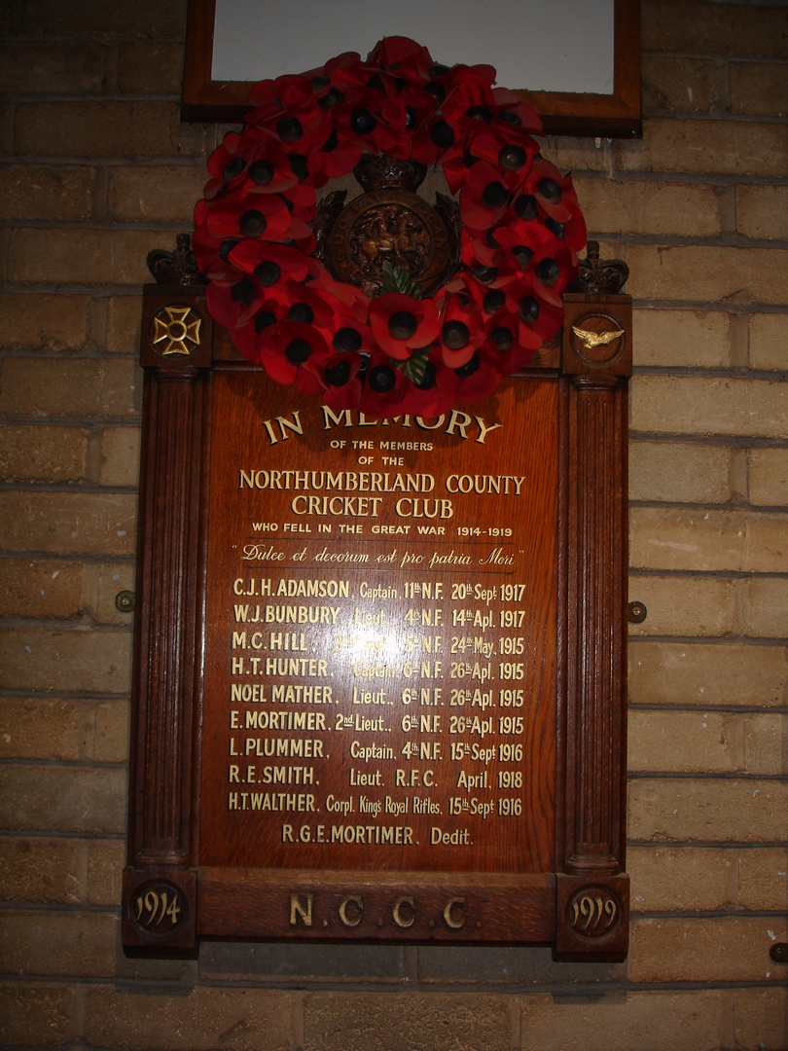
CJH ADAMSON Captain, 11th NF, 20th Sept 1917
WJ BUNBURY Lieut, 4th NF, 14th April 1917
MC HILL Lieut, 5th NF, 24th May 1915
HT HUNTER, Captain, 6th NF, 26th April 1915
NOEL MATHER Lieut, 6th NF, 26th April 1915
E MORTIMER 2nd Lieut, 6th NF, 26th April 1915
L PLUMMER Captain, 4th NF, 15th Sept 1915
RE SMITH Lieut, RFC April 1918
HT WALTHER Corp King’s Royal 15th Sept 1916
Rifles

It is noticeable that three members of the Cricket Club fell together on May 26th 1915. This was the Battle of St Julien near Ypres in Belgium.

Jesmond Methodist Church – St George’s Terrace
A brass plate set in a wooden frame is inscribed:

THIS TABLET IS DEDICATED/TO THE GLORY OF GOD IN/PROUD AND LOVING MEMORY OF THE/ UNDERMENTIONED MEMBERS OF/ THIS CHURCH AND CONGREGATION/ WHO GAVE THEIR LIVES IN THE/ CAUSE OF FREEDOM/ DURING THE GREAT WAR 1914-1918

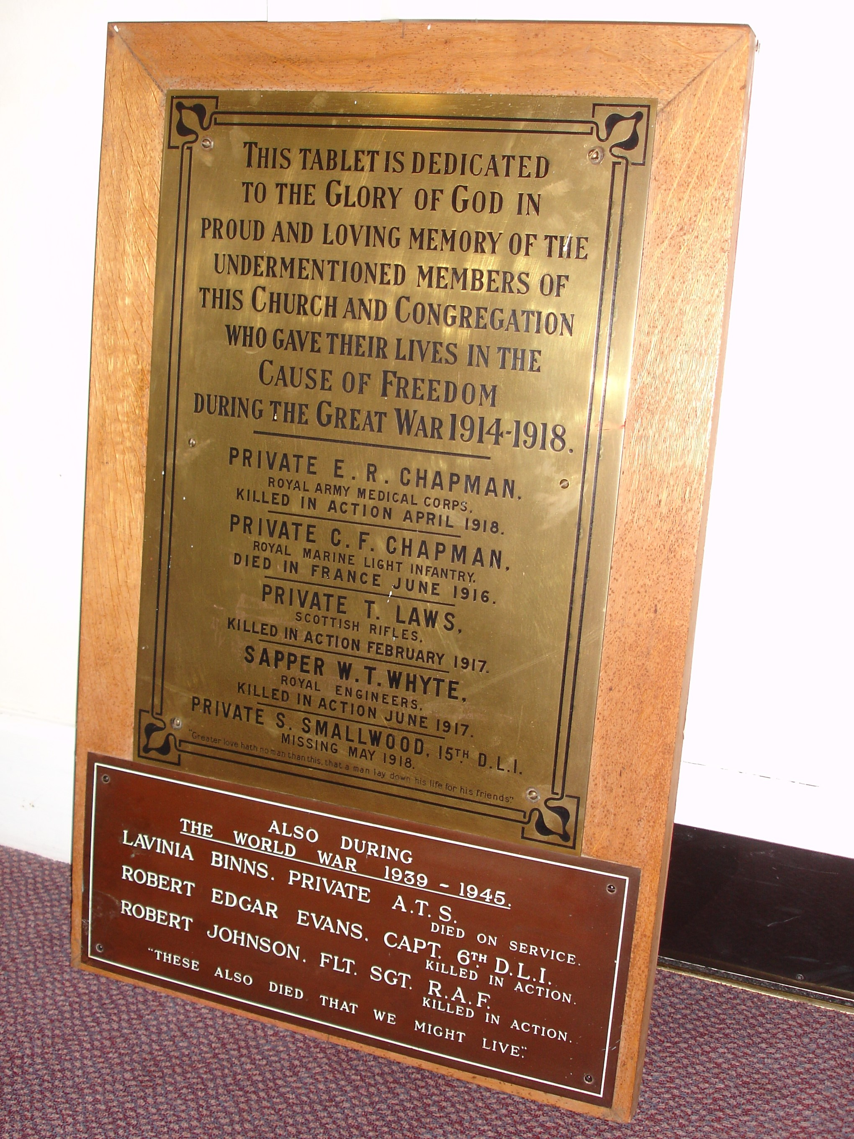
Private ER CHAPMAN Royal Army Medical Corps, killed in action April 1918
Private CF CHAPMAN Royal Marine Light Infantry, died in France June 1916
Private T LAWS Scottish Rifles, killed in action February 1917
Sapper WT WHYTE Royal Engineers, killed in action June 1917
Private S SMALLWOOD 15th DLI, Missing May 1918

Greater love hath no man than this – that a man lay down his life for his friends

Charles Fawcett Chapman (b.1897) and Edgar Ridley Chapman (b.1891) were brothers. They were living at 98 Holly Avenue Jesmond in the census of 1911. Charles enlisted in November 1915 when he could have been scarcely 18 years old. He was a non-combatant, serving as a medic with a field ambulance unit. He “died in France” of appendicitis in hospital in Abbeville and is buried in Abbeville Communal Cemetery. Edgar Ridley Chapman also served with a field ambulance division of the RAMC. He is buried in Ploegsteert Memorial Cemetery near Ypres in Belgium. Their parents Charles Alfred and Annie Chapman were then living at 20 Bath Terrace in Gosforth in 1916. They had an older daughter but no other sons. As with tens of thousands of similarly bereaved parents the telegrams must have hit them so hard.

Jesmond Parish Church
Founded in 1861 as Jesmond’s first parish church, then known as the Clayton Memorial Church, it was one of last works of the celebrated local architect John Dobson (in fact it was his last church). It is most unusual as an Anglican church not named after a saint.

A First World War memorial screen, (strictly a “dwarf screen”) dedicated in 1922 is in front of the chancel. It is in oak, divided into two sections each with three panels and inscribed with the names of 75 servicemen who lost their lives in 1914-18. Above the names, across both sections are the words “Greater love hath no man than this that a man lay down his life for his friends” (John 15:13).

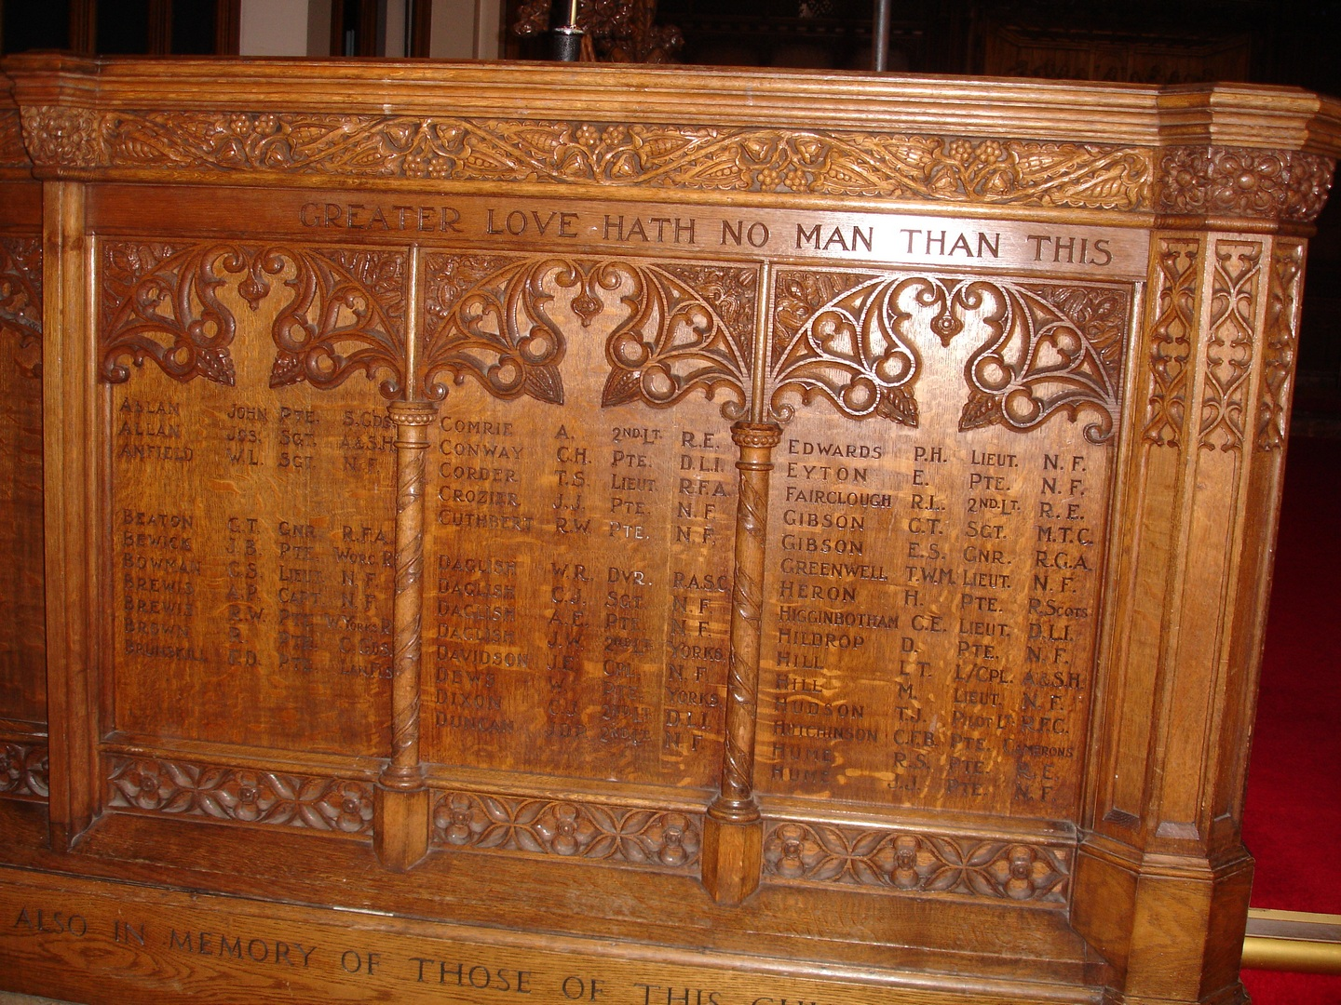

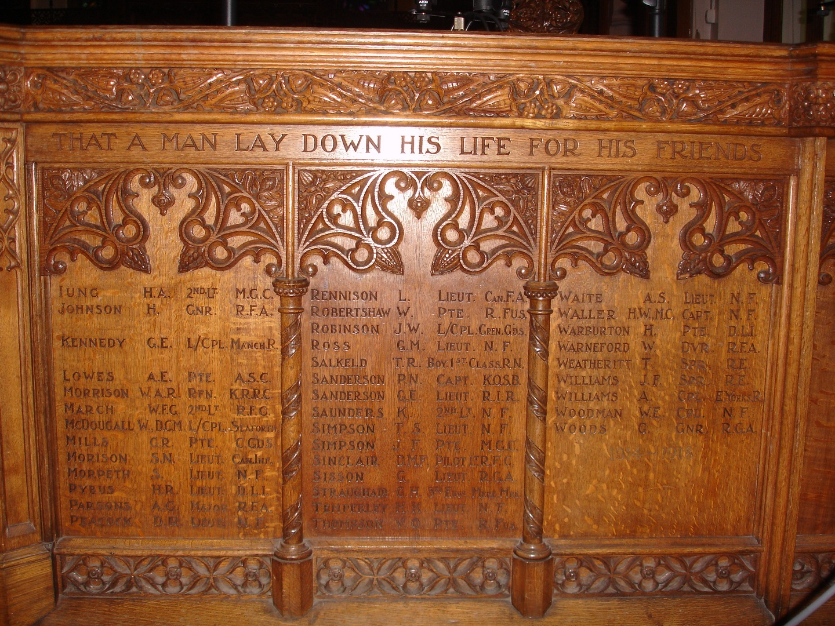

The names, as inscribed, are:

Allan John Pte S. Ches
Allan Jos Sgt A+SH
Anfield WL Sgt NF
Beaton GT Gnr RFA
Bewick JB Pte Worc R
Bowman GS Lieut NF
Brewis AP Capt NF
Brewis RW Pte W Yorks R
Brown R Pte G G’DS
Brunskill FP Pte Lan Fus
Comrie A 2nd Lt RE
Conway CH Pte DLI
Corder TS Lieut RFA
Crozier JS Pte NF
Cuthbert RW Pte NF
Daglish WR Dvr RASC
Daglish CJ Sgt NF
Daglish AE Pte NF
Daglish JW 2nd Lt Yorks
Davidson JE CPL NF
Dews W Pte Yorks
Dixon CJ 2nd Lt DLI
Duncan JDP 2nd Lt NF
Edwards PH Lieut NF
Eyton E Pte NF
Fairclough RL 2nd Lt RE
Gibson GT Sgt MTC
Gibson ES Gnr RGA
Greenwell TWM Lieut NF
Heron H Pte R Scots
Higginbotham GE Lieut DLI
Hildrop D Pte RE
Hill LT L/CPL A+SH
Hill M Lieut NF
Hudson TJ Pilot Lt RFC
Hutchinson CFB Pte Camerons
Hume RS Pte RE
Hume JJ Pte NF
Iung HA 2nd Lt MGC
Johnson H Gnr RFA
Kennedy GE L/CPL Manch. R
Lowes AE Pte RASC
Morrison WAR Rfm KRRC
March WFG 2nd Lt RFC
McDougall W DCM L/CPL Seaforth
Mills GR Pte G. GDs
Morison SN Lieut Can Inf
Morpeth S Lieut NF
Pybus HR Lieut DLI
Parsons AG Major RFA
Peacock DR Lieut NF
Rennison L Lieut Can FA
Robertshaw W Pte R Fus
Robonson JW L/CPL Gren Gds
Ross GM Lieut NF
Salkeld TR Boy 1st Class RN
Sanderson PN Capt KOSB
Sanderson GE Lieut RIR
Saunders K 2nd Lt NF
Simpson JF Pte MGC
Simpson TS Lieut NF
Sinclair DMF Pilot Lt RFC
Sisson G Lieut RGA
Straughair GH 3rd Eng Merc Mar
Temperley HK Lieut NF
Thompson VO Pte R Fus
Waite AS Lieut NF
Waller HW MC Capt NF
Warburton H Pte DLI
Warneford W Dvr RFA
Weatheritt T Spr RE
Williams JF Spr RE
Williams A CPL E Yorks R
Woodman WE CPL NF
Woods G GNR RGA

In addition there is a plaque in the church inscribed: Charles John (Ian) Dixon, 2nd Lt DLI, 08.04.1898 – 22.06.1917. He was the only son of the late Charles Rochester Dixon of Jesmond and the late Mary Isabella Anderson of Morpeth. He was educated in St Bees, Cumberland and the Royal Grammar School (where his name is inscribed on the Roll of Honour) before entering the Royal College of Music in London. He joined the Durham Volunteer OTC on his 18th birthday and transferred to the Cadet Corps in Jan 1917. He was gazetted 2nd Durham Light Infantry on 8th May 1917 one month after his 19th birthday. Only at the age of 19 was he allowed to serve abroad. He served with the Expeditionary Force in France from the 1st June and was killed in action near Arras on the 22nd. His body rests at Wancourt, France.

Albert Edward Lowes also has a plaque in the church. It is inscribed:

In memory of
Albert Edward Lowes, ARIBA,
Of the Northumberland Divisional Train ASC
Born August 26th 1888:
Killed in action at Ypres, April 26th, 1915:
A devoted Christian: a skilful Architect: a good Soldier.
“Ars longa, vita brevis”
Erected by his mother

The Latin quotation means “Art is long (lasts for ever), life is short”. Lowes’ name is carved on the Menin Gate. He was a Driver.

Charles and Arthur Daglish were brothers who lived at 218 Doncaster Road, Sandyford.

Major AG Parsons was the son of Sir Charles and Lady Katherine Parsons. His name is also on the war memorial in Wylam where his family then lived.

Royal Grammar School
The official school history is by Brian Mains and Anthony Tuck (1986). In pp 165-177 they refer to the “radical change” undergone by the school after the outbreak of the Great War. Two assistant masters left the school in 1914 on military service and “many others would follow”. As a result there was serious understaffing “partially met by a succession of temporary appointments including part-time clergymen from reserved occupations, and women teachers to the preparatory department.”

The school playing field was used by the OTC and the premises were used by St John’s Ambulance groups. Armstrong College used a chemistry lab three afternoons a week and on Saturday mornings (the college itself was being used as a temp RAMC hospital). Serious consideration was given to requests for the school to become a billet for 600 soldiers and also to be taken over as a military hospital. In the event neither materialised (p.171). In December 1916 cadets from the OTC assisted in the digging of trenches for the defence of Newcastle. An Agricultural Society was formed which cultivated a plot of land for potatoes and artichokes. Other boys went potato picking, hay-making, thistle-cutting etc. Boys also helped by writing out more than 13,000 meal cards for the Local Food Committee.

The Head Master, Mr Talbot, was made Major of the 1st Commercials (Quayside) Battalion of the Northumberland Fusiliers. The school OTC numbers rose to 140. Sir Arthur Munro Sutherland provided a rifle range on the edge of the school field which at times resembled a barrack square. The first death came at Ypres in November 1914. By 1915 107 old boys were holding commissions and 113 were serving in the ranks. During the Prize Day of 1921 the HM announced 1114 past scholars and masters on the school Roll of Honour of whom 138 had died and 150 had been wounded. Almost 100 had won decorations or had been mentioned in despatches.

The organ, made by JJ Binns and presented by Sir Arthur Sutherland in 1923, is a registered war memorial. It is inscribed “Dulce et Decorum est Pro Patria Mori” and records on 13 oak panels the names of 162 pupils (and staff) of the school who lost their lives in the Great War. These names, plus those from World War Two, have been gilded and are inscribed in the woodwork. The organ was restored in 2014.

A Book of Remembrance 1914-18 was published in May 1923 priced two shillings. It has biographical notes on 156 men who died during the war and six who died afterwards as a result of the war. A copy was presented to the relatives of those killed. It is inscribed:

This Memorial Volume is dedicated to
Old Novocastrians of all generations who
in it may learn how much they owe to
those brave men, who, at the call of duty,
fought for the honour of their country,
and, following the great example, willingly
laid down their lives for others

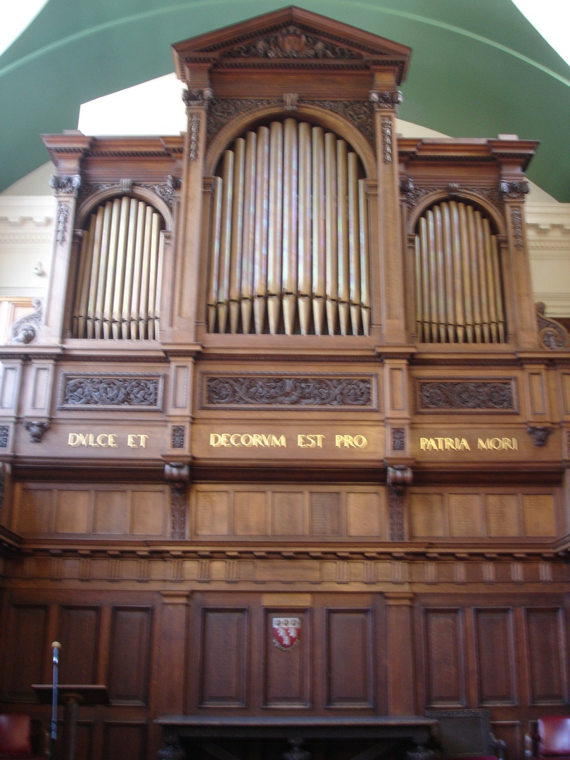

All names and brief biographies are included in the North East Memorials Project website.

St Andrew’s Cemetery
Has a Cross of Sacrifice of standard design by Sir Reginald Blomfield. It was unveiled in June 1924 and is approx six metres high on an octagonal base. It is inscribed “To the honoured memory of five hundred and eighty eight sailors and soldiers who gave their lives for their country during the Great War 1914-18 one hundred and seventy nine of whom lie here”. The remaining 409 are buried in official Imperial war graves in cemeteries across Newcastle, including in Jesmond All Saints and in Jesmond Old (Private) Cemetery.

Around the Cross are 218 named war graves, including a grave for Private GW Scattergood who died, poor soul, on November 11th, 1918.

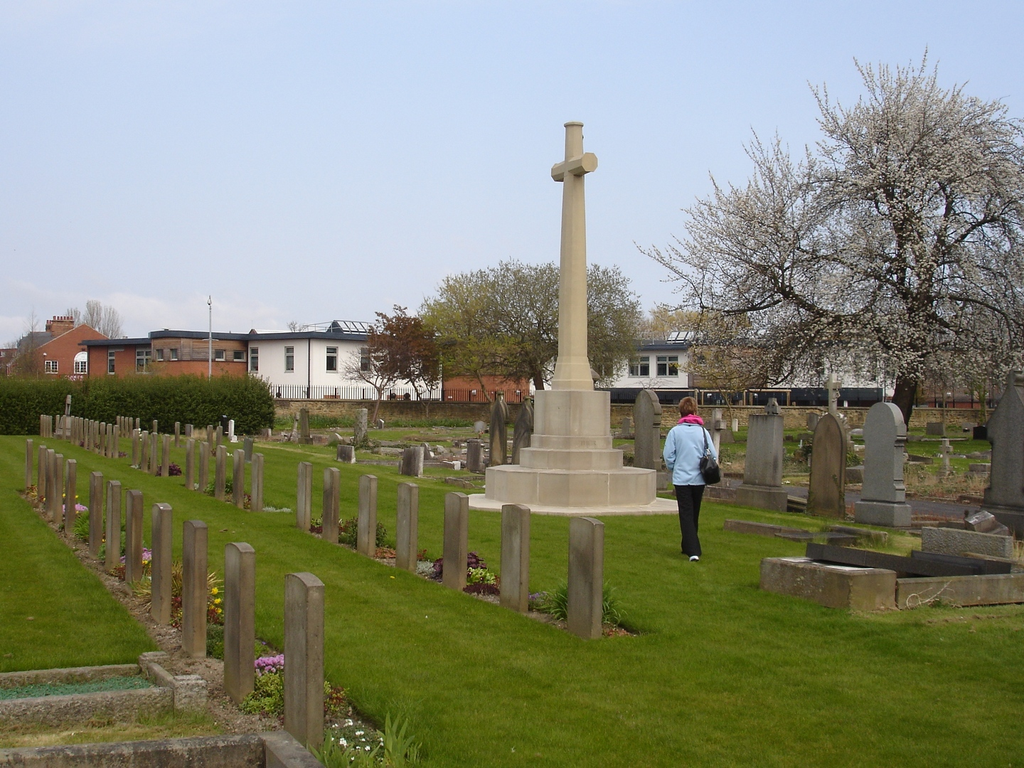

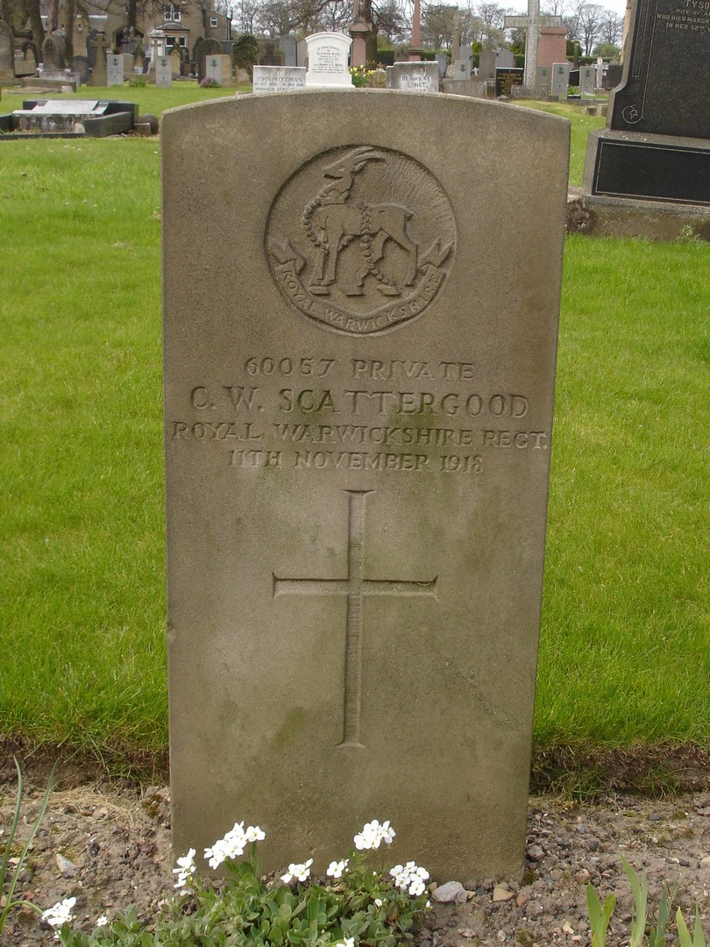
Six of those buried in the war graves in the cemetery are known to have been from Jesmond and Bobbie Harding has provided details. They were:

LIEUTENANT JOHN HENRY BETTS, Royal Navy (HMS President)
DoD 29 March 1918 aged 55
Husband of Phoebe Betts, 20 Mayfair Rd, West Jesmond

GUNNER CLIFFORD BUCK 148126 Royal Garrison Artillery
DoD 17 February 1917 aged 19
Only child of Henry James (Insurance Agt) & Fanny Buck, 58 Glenthorn Rd, Jesmond.

PRIVATE HARRY SEMMONS DONKIN 302284 Royal Scots
DoD 17 May 1918 aged 19. Further information is given below.
Son of William Thompson and Margaret Fletcher Donkin, 9 Lavender Gardens, West Jesmond (native of Sunderland).

BOMBADIER FRANK WILLIAM HALL 755805 Royal Field Artillery, 4th Reserve Bridgade
DoD 6 April 1920 aged 29
Husband of Jennie Hall, 2 Oakland Rd, West Jesmond

PRIVATE GEORGE WILLIAM ALLAN LIVINGSTONE 19133 2nd Unit South African Infantry - Army
DoD 23 October 1918 (no details re age)
Son of Mary & late George Livingstone, 37 Hazlewood Ave, Jesmond

PRIVATE ERNEST WRIGHT 975 1st Btn Northern Cyclists Btn Army Cyclists Corps Army.
DoD 30 July 1915 aged 22
Son of Mr J J Wright, 49 Devonshire Place, Jesmond

Bobbie Harding has provided the following information relating to Private Harry Semmons Donkin.

He was born on 31 July 1898 so he was underage when he joined the army in Newcastle on 19 Feb 1916.

He joined the 19th BN Kings Royal Rifle Corps. On the 4 July 1916 a few weeks before his eighteenth birthday he was posted to France. On the 4th Oct 1916 he was withdrawn from the firing line and sent back to UK on 26th Nov when it was discovered he was under 19, the age when boys could be posted overseas. Soon after arrival back in UK, he was transferred on 15 Dec 1916 to 2/7BN Royal Scots. On 5 May 1917 he was appointed unpaid acting lance corporal. He was granted leave from 7-11 Jun 1917 and appointed paid acting l/cpl on 21 Jun 1917. He was granted embarkation leave from 8-17 Oct 1917. On the 18 Oct he was transferred to 1/8 BN Royal Scots (part of the BEF) and reverted to private.

On arrival in France he was posted to the 1/9 BN Royal Scots on 22nd Oct 1917. On 6 Feb 1918 1/9 BN transferred to 183rd Brigade, 61st (South Midland) Division. On 21 March 1918, the enemy launched what was intended to be a decisive offensive, attacking the British Fifth and Third Armies on the Somme in overwhelming strength. The 61st (2nd South Midland) Division was holding the forward zone of defences in the area northwest of Saint Quentin in the area of Ham and lost many men as it fought a chaotic but ultimately successful withdrawal back over the Somme crossings over the next ten days. In the initial clash, the South Midland faced three enemy Divisions and only began to retire on the afternoon of 22 March, when ordered to do so in consequence of the enemy's progress at other parts of the line.

Harry Donkin was wounded on 24 Mar 1918. He was admitted to the 53 Casualty clearing station (possibly in Namps au Val) with a gun shot wound (GSW) in the back. On 28th Mar he was transferred to the 9th General Hospital in Rouen. The hospital was extremely busy at the time as 1,125 patients were admitted the previous day 27th Mar 1918. He left France on 31 Mar arriving back in UK on 1st Apr 1918. On 1st Apr he was posted to depot BN. The doctors report is difficult to read:
"[This was] a very difficult and very severe case The wound appeared [?], in spite of which his temperature kept up. An exploratory operation was performed his sinus enlarged [?]. Negative result. Exploratory needlings were done in his pleural cavity and elsewhere. [?] a deep pocket of foetid puss was found [surr]ounding a piece of shrapnel. He became [?] and developed double pneumonia [?] effusion and pericarditis [He] died on May 17/18".

A telegram was sent from the Hospital to the records office in Hamilton.
"O.I.C.Records No2 district Hamilton. Regret report death at Station Road Hospital Gillingham Dorset 302254 Pte Donkin 9BN Royal Scots 12 Noon 17th inst septic pneumonia following G.S. Next of kin present no will body will be removed Newcastle Red Cross"

Private Donkin is also commemorated on the plaque at West Jesmond School

St George’s Church
There is a handsome brass and alabaster memorial on the north wall. It was designed by the architect HL Hicks and is beautifully inscribed with 43 names below the words:

TO THE
GLORY OF GOD
AND IN EVER GRATEFUL MEMORY
OF THOSE WHOSE NAMES ARE SET OUT
HEREUNDER WHO FELL IN THE GREAT WAR
1914-1919

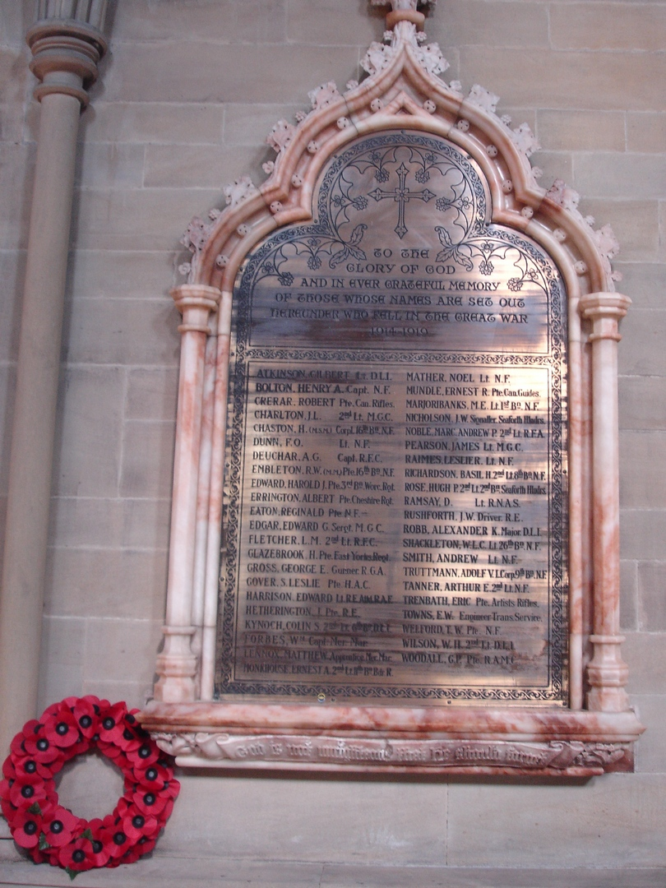

Along the bottom of the frame the words “God is not unrighteous that he should forget” are carved in Gothic script.

The plaque was unveiled in December 1920 by Major Charles Mitchell, DSO of the 2nd Grenadier Guards. He was the grandson of Charles William Mitchell the local shipbuilder and founder of the church. The plaque was dedicated by Dr Wild, the Bishop of Newcastle.

ATKINSON, GILBERT Lt. DLI
BOLTON, HENRY A. Capt NF
CHARLTON, JL 2nd Lt MGC

CHASTON, H (msm) Corpl 16th Bn NF
CRERAR, ROBERT Pte Can Rifles
DEUCHAR, AG Capt RFC
DUNN, FO Lt NF
EATON, REGINALD Pte NF
EDGAR, EDWARD G Sergt MGC
EDWARD, HAROLD J Pte 3rd Bn Worc Rgt
EMBLETON, RW (mm) Pte 16th Bn NF
ERRINGTON, ALBERT Pte Cheshire Rgt
FLETCHER, LM 2nd Lt RFC
GLAZEBROOK, H Pte East Yorks Regt
GOVER, S LESLIE Pte HAC
GROSS, GEORGE Gunner RGA
HARRISON, EDWARD Lt RF, attd RAF
HETHERINGTON, J Pte RE
KYNOCH, COLIN S 2nd Lt 6th Bn DLI
*FORBES, Wm Capt Mer Mar
LENNOX, MATTHEW Apprentice, Mer Mar
MARJORIBANKS, ME Lt 1st Bn NF
MATHER, NOEL Lt NF
MONKHOUSE, ERNEST A 2nd Lt 11th Bn Bdr R
-------------------------------------------------------------------------
MUNDLE, ERNEST R Pte Can Guides
NICHOLSON, JW Signaller, Seaforth Hlndrs
NOBLE, MARC. ANDREW P 2nd Lt RFA
PEARSON, JAMES Lt MGC
RAIMES, LESLIE R Lt NF
RAMSAY, D Lt RNAS
RICHARDSON, BASIL H 2nd Lt 8th Bn NF
ROBB, ALEXANDER K Major DLI
ROSE, HUGH P 2nd Lt Bn Seaforth Hlndrs
RUSHFORTH, JW Driver RE
SHACKLETON WLC Lt 26th Bn NF
SMITH, ANDREW Lt NF
TANNER, ARTHUR E 2nd Lt NF
TOWNS, EW Engineer Trans. Service
TRENBATH, ERIC Pte Artists Rifles
TRUTTMANN, ADOLF V L Corp 9th Bn NF
WELFORD, TW Pte NF
WILSON, WH 2nd Lt DLI
WOODALL, GP Pte RAMC

*The name Forbes is out of alphabetical order and has replaced a name which has been removed. Barbara Peacock has discovered that William Forbes was a master mariner who died of cerebral thrombosis while at sea on active service in 1916. Barbara suggests he may have replaced Lt G Lacey of the RFC who possibly survived the war as a prisoner.

The names recorded were to be those of parishioners or members of the congregation whose names “were not recorded in any other place of worship”. Interestingly, and despite this stipulation, the names H GLAZEBROOK, M LENNOX , HP ROSE and GP WOODALL are also to be found on commemoration plaques either in St Hilda’s or in the United Reform Church. The name ANDREW SMITH is engraved on the memorial screen from St George’s Drill Hall, now in the church of St Thomas the Martyr on Barras Bridge.

A former colleague of mine, aware of my interest in this project, passed on the following information. William Launcelot Collier Shackleton was born in 1886, the son of William and Louisa Shackleton. The family lived at 64 St. George’s Terrace, Jesmond. Mr Shackleton Snr. was a commercial traveller. Lance attended the Royal Grammar School between 1897 and 1903. He then trained as an engineer and was a member of the North East Coast Institution of Engineers and Shipbuilders. He joined the 26th Battalion of the Northumberland Fusiliers (Tyneside Irish) and was commissioned in December 1914. He was promoted to Lieutenant in April 1915.

Lance left for France in January 1916. He was wounded on 13th May 1916 in the trenches near Albert. He returned home on sick leave and thus missed the beginning of the Somme offensive. The 26th Battalion lost so many of its men during that battle that it was amalgamated with the 25th Battalion.

Whilst in the army, Lance corresponded with Mary Swinburn (known as Mally) who lived in Rectory Terrace, Gosforth. They married on 14th June 1916 at Gosforth Parish Church (St. George’s). This was during Lance’s sick leave. He returned to France on 27th October 1916. He was again wounded on 23rd April 1917 and had his wounds dressed. He died of wounds the following day during an attempt by his platoon to capture the Chemical Works and Chateau at Rouex near Arras. His brother-in-law, Captain George Swinburn, with the help of the Methodist Padre, eventually managed to recover his body. Lance is buried in Crump Trench Cemetery, Fampoux.

Mally never remarried. We have no details of what she did after Lance’s death but
certainly she lived for some years with Lance’s elderly parents in St. George’s Terrace. She died in January 1964. She is buried with her parents-in-law in St Andrew’s cemetery, Jesmond.

We became interested in Lance when my husband John found that there were letters from him to Mally in envelopes he had bought for philatelic purposes. On reading a book about the Tyneside Irish by John Sheen, (Pen and Sword Books Ltd) John realised that letters quoted there were also from Lance. The book gave us details of how Lance had died. John contacted the author, John Sheen, whom we visited. He was enormously helpful and very knowledgeable. He was able to give us contact details for descendants of Mally’s family. We visited them and gave them Lance’s letters. They remembered that after her son’s death Mrs Shackleton Snr kept Lance’s bedroom exactly as he had left it.

The name Adolph Truttmann is perhaps a surprising one. His full name was Adolphus Victor Truttman, born in Newcastle in 1891. He was one of seven children and the only son of Philip and Isabella Truttmann, his father being an Italian-born fancy goods merchant. In 1911 the family were living locally at 3, Mitchell Avenue.

Adolph served as a Lance Corporal with the Northumberland Fusiliers. He was killed on the Somme on July 7th 1916 exactly one week after the start of the offensive. He has no grave but his family placed a headstone in his memory in St Andrew’s cemetery. His name is also one of more than 72,000 inscibed on the Thiepval Memorial in France.

St Hilda’s Church
There is a wall-mounted wooden tablet in excellent condition in the north aisle with 38 names. The dedication, in gold-plated lettering, reads:

“In Memoriam. For those who gave their lives for us in the Great War RIP”.

F Anderson
PR Anderson
H Bell
HJ Blackshaw
WV Burdock
SK Bygath
R Craig
CEC Doyle
R Edminson
RW Embleton
B Errington
P Fenwick
H Glazebrook
WH Glazebrook
D Goodman
TWM Greenwell
JM Kent
GH Lambert
M Lennox
WE Light
W Macaulay
TS Maslin
CN Merritt
EM Mills
H Muir
A Padgham
H Reed
G Robson
PJ Robson
JW Scott
S Smallwood
A Snowdon
W Soulsby
PA Tavener
W Turner
FL Vernon
GP Woodall
HS Donkin

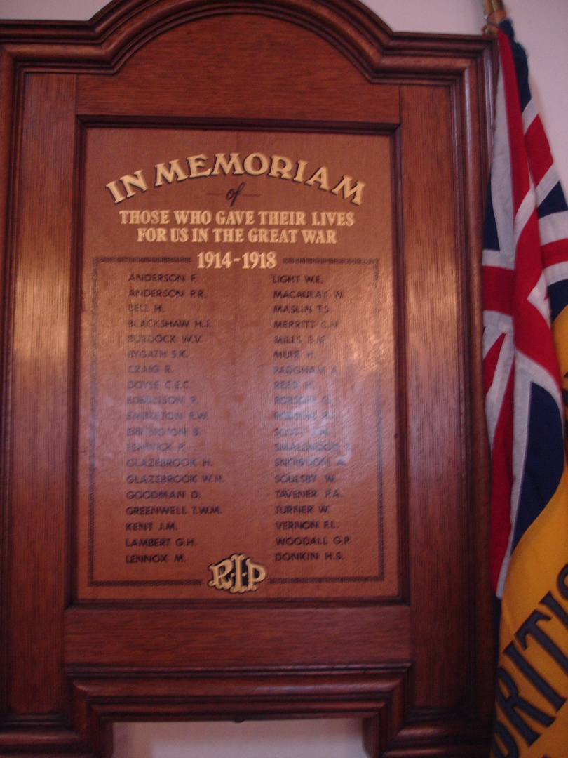

St Hilda’s has a second memorial to those who fell in the conflict of 1914-18. This is the Newbery Triptych which takes its name form the artist. This triple-panelled screen painting was planned from April 1919 by the St Hilda’s War Memorial Sub-Committee. It was on display at the Laing by July 1920 before being installed at St Hilda’s on 14.11.1920. The Vicar was RF Smyth and the churchwardens were OB Richardson and KH Vickers. The triptych measures 145 cms high × 213 cms when the side doors (each measuring 106.5 cms) are closed.

The artist, Francis H Newbery (1855-1946) was the Principal of Glasgow School of Art and one of the co-founders of the Glasgow School. Newbery was known sometimes to present his works without any charge (qv leaflet from St Hilda’s). Newbery’s monogram is in RH corner of the centre panel. It is not recorded whether there were any costs to the church arising from the commissioning of this fine work. Any costs raised by the church would have been substantial for a work such as this.

The triptych of three painted wooden panels is an unusual blend of Northumbrian history and Christian symbolism as well as being a commemoration of those who lost their lives in the Great War. The central tableau shows gifts being presented to a new-born babe. The Virgin Mary with Jesus standing on her knee are shown on the banks of the Tyne with St Hilda, the Abbess of Whitby looking on and holding her church. Life and industry on the Tyne are depicted by a Cullercoats fishwife, a miner, an engineer, a ship-worker and St Nicholas. Their gifts represent local industry ie coal, herring, ship-building and a railway engine.

It has two outer panels of the closed doors, both painted, which show the Annunciation set in a flower garden. The two grieving women with flowers are possibly Newbery’s wife and daughter. There is a full description in the pamphlet. These external panels are significantly faded.

The left panel depicts a Roman centurion, showing that Newcastle originated with the Romans. Beside him is a Norman knight. The latter appears before the castle keep (with anachronistic battlements and flag turret) and the Black Gate.

The right panel shows “Heroes of the War”. A sailor holds a signal glass beside a soldier in the full trench uniform of the Northumberland Fusiliers, both against a background of wartime devastation.

It is inscribed “To the glory of God and in loving memory of the men of this Congregation and parish who died for their Country in the war 1914-1919.”

The triptych was originally installed behind the altar in the Lady Chapel. It was moved to its present position in the north aisle in 1954. It was sent to Glasgow in 1996 to figure in an exhibition of Newbery’s work at the Glasgow School of Art.

It is not in best of condition because of fading paintwork and colours, especially on the outer panels. Newbery painted directly onto board and did not use varnish, which apparently rules out restoration.

St Thomas the Martyr, Barras Bridge
(This memorial screen was relocated from St George’s Drill Hall, Northumberland Road)

All the names are officers of the 6th Battalion of the Northumberland Fusiliers and the following were from Jesmond.

HENRY LAURENCE BENSON, 2nd Lt, died aged 26 on 11th November 1916.
Son of Harry and Minnie Benson of Denehurst, Jesmond Park East
GEORGE SHERIFF HARKUS JACQUES, 2nd Lt, died aged 20 on 27th June 1916.
Only son of Isaac W and MF Jacques of 61, Osborne Avenue, Jesmond
STANLEY MORPETH, Lt, died aged 22 on 22nd October 1918.
Son of Joseph and Margaret Morpeth of 20, Eslington Terrace
ANDREW SMITH, 2nd Lt, died aged 22 on 14th November 1916.
Son of Andrew and Una Jane Smith of 114, Fern Avenue, Jesmond.

United Reform Church
This church was originally a Presbyterian Church of 1888 and was contemporary with St George’s Church. It combined with the Congregationalist Church in 1972 to form the United Reform Church.

It has a bronze memorial plaque unveiled in 1921 and consisting of five separate panels each with finely executed figures in a relief tableau. From left to right they are: a Great War captain in uniform with a nurse, St George (with slain dragon), a Calvary with two angels at the feet of Christ, St Michael, and a sailor with a mother and child. The pilasters dividing the panels have a cherub’s face at the base. At the very top of the memorial are images of a shamrock, thistle and rose.

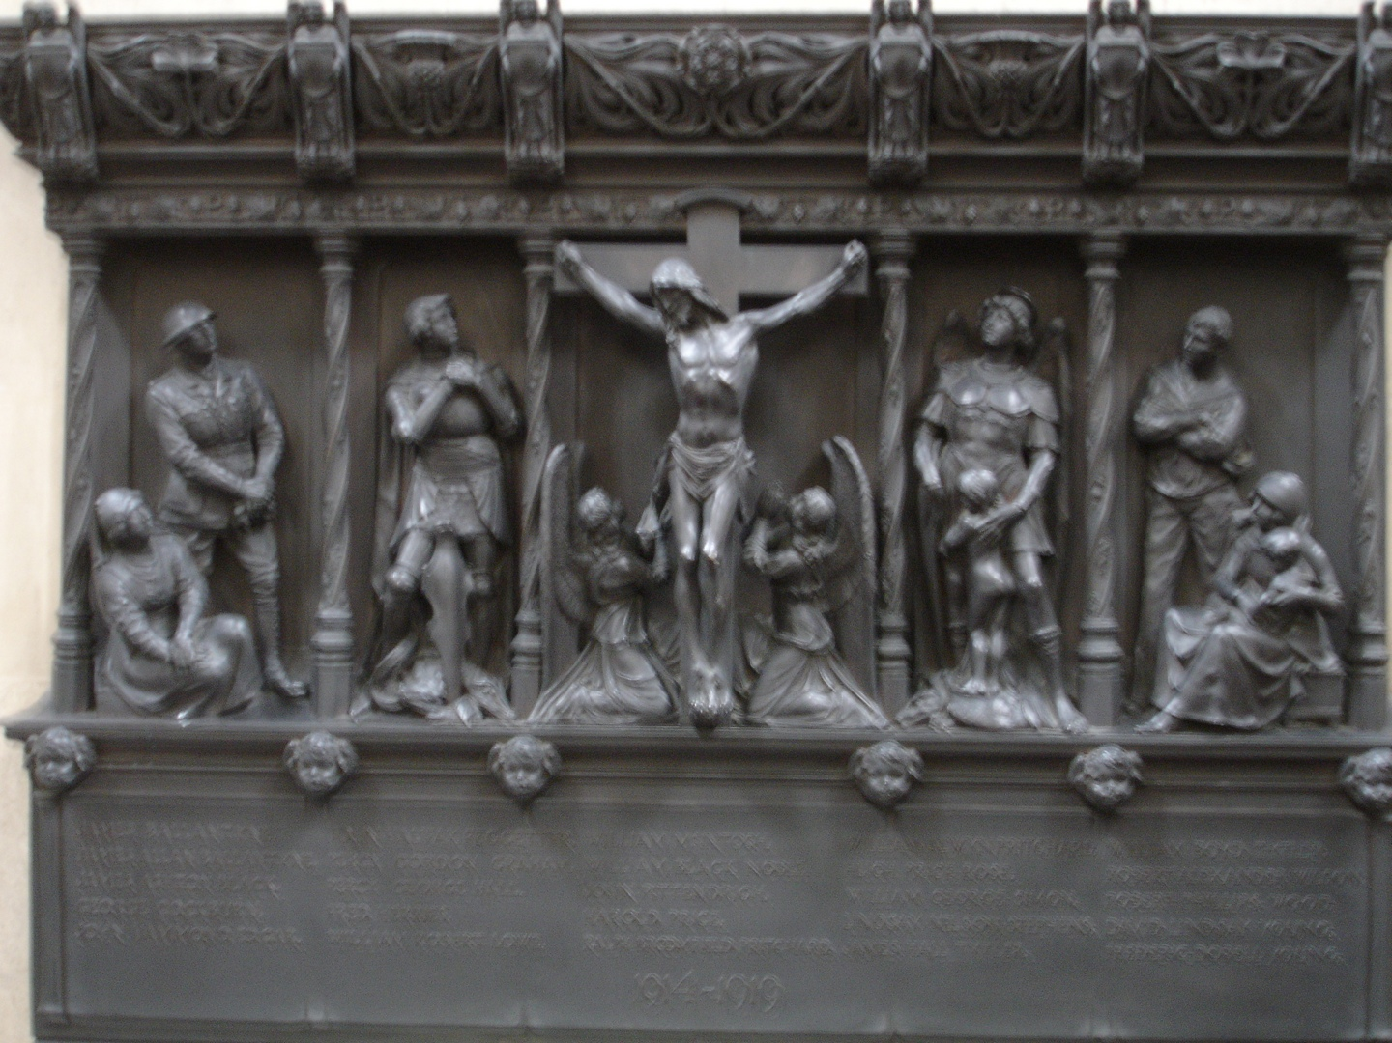

The memorial has 25 names set out in five panels immediately below the tableau. The names are those of the congregation who lost their lives in the Great War. They were:

JAMES BALLANTYNE
JAMES ALAN BALLANTYNE
JAMES ASHTON BLACK
GEORGE COCKBURN
JOHN HAMMOND EDGAR
JOHN HALIFAX FEGGETTER
PERCY GORDON GRAHAM
PERCY GEORGE HALL
FRED HERRIES
WILLIAM ROBERT LOWE
WILLIAM McINTOSH
WILLIAM BLACK NOBLE
JOHN PITTENDRIGH
HAROLD PRICE
RALPH BROOMFIELD PRITCHARD
WILLIAM ALWYN PRITCHARD
HUGH PRICE ROSE
WILLIAM GEORGE SIMON
LINDSAY NELSON STEPHENS
JAMES HALL TYTLER
WILLIAM BOYD TYTLER
ROBERT ALEXANDER WILSON
ROBERT PHILLIPS WOOD
DAVID LINDSAY YOUNG
FREDERICK DOBELL YOUNG

The unveiling ceremony was performed, with deep pathos, by Mr JT Young whose son David Lindsay Young was one of the fallen.

“The sight of the white-haired father, the cord of the flag which veiled the bronze trembling in his fingers, and his lips quivering as he laid the laurel wreath in its place at the foot of the tablet, brough home to the younger members of the congregation the sorrow and grief which have been the portion of so many parents who loved and gave - their all.” (Quoted from the NE War Memorials Project website).

At the foot of the wall-mounted plaque, below a complementary plaque to honour the dead in WW2, is the inscription “No man liveth under himself, no man dieth under himself”. (Romans 14:7.)

No fewer than eight of the dead were killed on July 1st 1916 – the first day of the Somme.

Lt John Halifax Fegetter MC has a clerestory window in the church dedicated in his honour. The window depicts Abraham and Isaac, an apparent reference to Abraham’s willingness to obey the Lord and to sacrifice his son. John Fegetter was born in Jesmond in 1895 and attended Rutherford College and Armstrong College. He was a teacher at the URC Sunday School. He died aged 22 at Passchendaele in October 1917. The NE War Memorials Project site has details of Lt Halifax’s gallantry as reported by his fellow officers. In the euphemism of the times “He was buried where he fell but the precise place is not known”. His name is recorded on the vast memorial at Tyne Cot near Ypres.

Percy George Hall was the son of Colonel JR Hall (1862-1953) of the Tyneside Scottish who has his own commemorative wall plaque in the church. He was an elder of the church and presented the Book of Remembrance referred to below.

There is a also a beautiful vellum-bound Book of Remembrance published in 1923 in remembrance of the First World War dead. This is written in beautiful copperplate script with a photograph of each of the 25 dead opposite which are biographical notes. These notes are also available on the North East War Memorials site. The book also contains the names of 81 men who served in the conflict and survived.

Robert and Alison Shiel of Clayton Rd Jesmond are members of the URC congregation and have made a special study of their church in the First World War. They have an archive of contemporary documents and have undertaken much research into the 25 men who were killed.

In particular they have a printed copy of the hand-written Book of Remembrance found in the church. It also contains a list of those from the congregation who served in the war and came through it. The Shiels therefore have names and details of all those from the church who were killed plus the names of others who served and returned home. They have also undertaken tours of the Somme and Flanders and visited the graves or memorial inscriptions of all 25 fallen men. These they have recorded and photographed and made into a booklet with information about the relevant cemetery and of the deceased.

Not all of those who died were local. Captain Harold Price MC was Canadian and had joined the 4th Battalion of the Tyneside Scottish Brigade (23rd Northumberland Fusiliers) which had been formed in six days in November 1914 and attached itself to the church. The URC had many links with the Tyneside Scottish (this having been a Presbyterian church). A brass plaque in a wooden frame gives the history and Battle Honours of the Brigade in 1916, 1917 and 1918.

A high proportion of those who lost their lives were officers, a fact which almost certainly reflects the social composition of the congregation from which they were drawn. 25 out of 106 men who enlisted died in the conflict. This represents a much higher proportion than is usually the case reflecting the fact that most were officers, and many of them junior officers.

To read the life histories of these 25 men; their promise, their courage, their optimism and their selflessness only serves to reinforce the waste, banality and futility of their deaths. One example will serve for all.

James Ashton Black was the son of two members of the church congregation. “He was educated at Newcastle Modern School, and at the outbreak of War was a clerk in a Shipbroker and Coal Exporter’s office on the Quayside, Newcastle. He was one of the first to volunteer in Newcastle for active service, he joining the 1st Commercials (16th Northumberland Fusiliers) as a Private in August 1914. He went to France in November, 1915, and with his Battalion took part in the first battle of the Somme, commencing 1st July, 1916, he being slightly wounded in the course of the fighting. He subsequently was gazetted as a Second-Lieutenant and posted to the 3rd Durham Light Infantry but attached to the 2nd Durham Light Infantry with which Battalion he served in France taking part in two engagements the last being on 21st March, 1918, on which date he was reported missing after fighting in the Cambrai district. Conflicting reports were received by his parents concerning him – one report stated he was badly wounded, taken prisoner, and died the next day being buried at Beauhill, near Prouville, and another report stating that he was killed by enemy shell fire. After his death his Commanding Officer wrote home in high terms of his bravery and absolute reliability. Age 22”.

March 21st 1918 was an infamous dates in the annals of the British Army. Through the winter of 1917-18 the Germans had been shifting their eastern forces to the Western Front. This followed their armistice with the Bolsheviks. At dawn on March 21st they launched a tremendous shell and mortar bombardment against the British trenches. The enhanced German forces, now one million strong, then struck in thick fog across the Somme area. 62 divisions advanced against 26 British divisions in a final desperate attempt to win the war, and it almost succeeded. The British line was blown wide open and within a few days the Germans had recovered all the territory secured yard by terrible yard amid four and a half months of fighting and slaughter in 1916 on the Somme. The British lost 150,000 men, 90,000 as prisoners on March 21st. One of these was James Ashton Black.

The colours were deposited in the church in June 1919 by survivors of the Battalion. They are away for restoration (in 2014) and it is intended that they be rededicated on July 1st 2016 and then properly mounted on a wall of the church.

West Jesmond Primary School
54 names of former teachers and pupils are inscribed on a shining bronzed copper plaque wall-mounted just inside the school. The enamelled Coat of Arms of the city is at the top. The plaque is attributed to JD Longstaff of the Handicrafts Guild of Armstrong College. It was unveiled in March 1921.

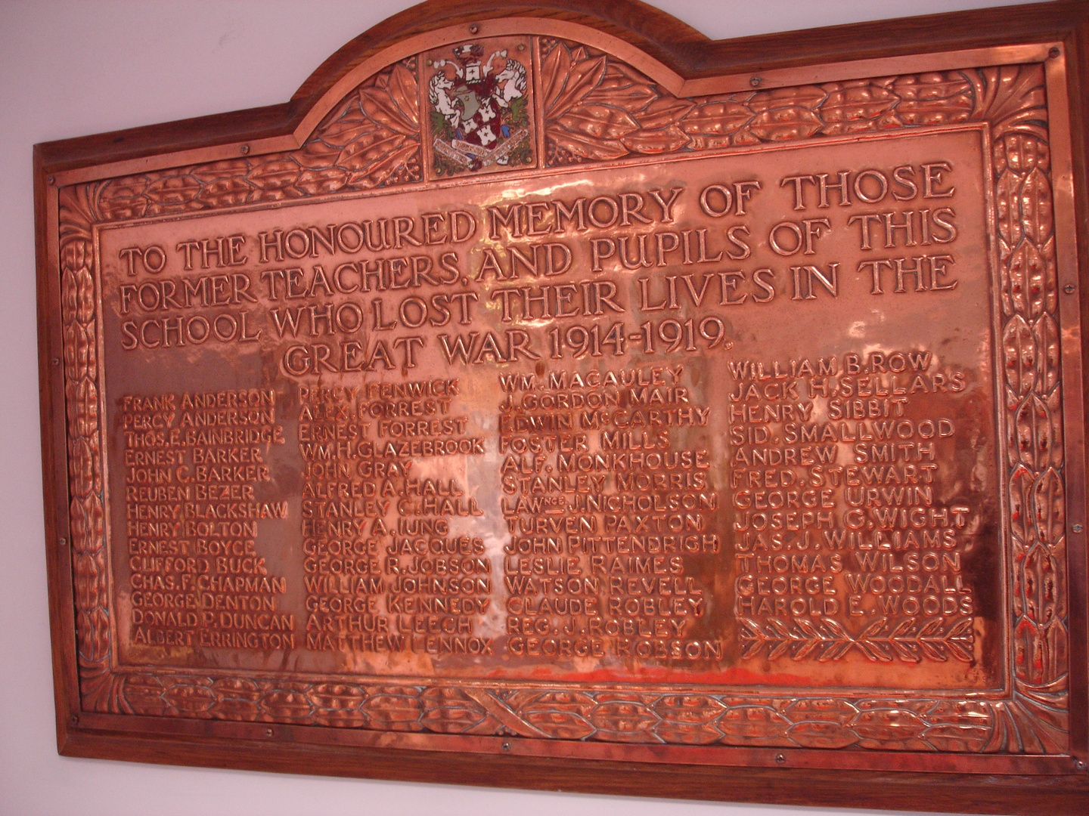
“TO THE HONOURED MEMORY OF THOSE FORMER TEACHERS, AND PUPILS OF THIS SHOOL WHO LOST THEIR LIVES IN THE GREAT WAR 1914-19”

Frank Anderson
Percy Anderson
Thomas E Bainbridge
Ernest Barker
John C Barker
Reuben Bezer
Henry Blackshaw
Henry Bolton
Ernest Boyce
Clifford Buck
Chas F Chapman
George Denton
Donald P Duncan
Albert Errington
Percy Fenwick
Alex Forrest
Ernest Forrest
William H Glazebrook John Gray
Alfred A Hall
Stanley C Hall
Henry A Iung
George Jacques
George R Jobson
William Johnson
George Kennedy
Arthur Leech
Matthew Lennox
Wm Macauley
J Gordon Mair
Edwin McCarthy
Foster Mills
Alf. Monkhouse
Stanley Morris
Lawrence J Nicholson
Turven Paxton
John Pittendrigh
Leslie Raimes
Watson Revell
Claude Robley
Reg J Robley
George Robson William B Row
Jack H Sellars
Henry Sibbit
Sid Smallwood
Andrew Smith
Fred Stewart
George Urwin
Joseph G Wight
Jas J Williams
Thomas Wilson
George Woodall
Harold E Woods

A Roll of Honour to the 376 former staff and pupils of the school who returned from the war was unveiled on the same day as the commemorative plaque. The names were printed in italic script on paper preserved behind glass in a wooden frame. It was kept alongside the bronzed plaque but is no longer there and its whereabouts are unknown. I have made enquiries with the school, but to no avail.

Albert Errington died in France in October 1918. His name is on the Roll of Honour of Bellringers in St Paul’s Cathedral, London. He rang the bells at St George’s Church. He is also named on the memorial to bellringers in St Nicholas’ Cathedral in Newcastle.

Henry Sibbit, born 1889, was a teacher at the school who became a Major with the Northumberland Fusiliers. He was the only WJPS teacher to have lost his life in the conflict. He was killed in action on July 1st 1916. He was 27 years old. His remains were never found in the turmoil and mass slaughter of that notorious first day of the Battle of the Somme. His name is one of more than 72,000 inscribed on the great memorial at Thiepval.

This overpowering number was only of those whose remains could not be identified, or were never found. This enormity is memorably recounted in Sebastian Faulks’ great novel Birdsong, In his book Faulks describes a first visit to Thiepval by a young woman, Elizabeth, who had developed an interest in an ancestor who had fought in the Great War.

As she came up to the arch Elizabeth saw with a start that it was written on. She went closer. She peered at the stone. There were names on it. Every grain of the surface had been carved with British names; their chiselled capitals rose from the level of her ankles to the height of the great arch itself; on every surface of every column as far as her eyes could see there were names teeming, reeling, over surfaces of yards, of hundreds of yards, over furlongs of stone.

She moved through the space beneath the arch where the man was sweeping. She found the other pillars identically marked, their faces obliterated on all sides by the names that were carved on them.

“Who are these, these….?” She gestured with her hand.
“These?” The man with the brush sounded surprised. “The lost.”
“Men who died in the battle?”
“No. The lost, the ones they did not find. The others are in the cemeteries.”
“These are just the … the unfound?” She looked at the vault above her head and then around in panic at the endless writing, as though the surface of the sky had been papered in footnotes. When she could speak again she said “From the whole war?”
The man shook his head. “Just these fields.” He gestured with his arm.

Elizabeth went through and sat on the steps on the other side of the monument. Beneath her was a formal garden with some rows of white headstones, each with a tended plant or flower at its base, each cleaned and beautiful in the weak winter sunlight.
“Nobody told me.” She ran her fingers with their red-painted nails back through her thick dark hair. “My God, nobody told me.”

Reflections
It was Joseph Stalin who said “The death of a million men is a statistic; the death of one man is a tragedy”? Any contemplation of the numbing loss of life in 1914-18 needs a focus, something to take us beyond the incomprehensible numbers and help us identify with those who fought, those who lost their lives and those who were left to mourn behind closed curtains. Sometimes a connection is made by a work of art, a piece of music, a poem or a family photograph but more often it will be a memorial honouring the names of those who would otherwise be forgotten. It is those personal identifiers, the names ages and sometimes other information symbolically and solemnly engraved so that others can pay their respects, contemplate and not forget. Here in Jesmond we are fortunate in having a number of such memorials which help to ensure that, one hundred years later, they shall not be forgotten. This report and the names it contains has been compiled as an act of remembrance for those who gave their lives.

John North

February 15th 2015

CALLED TO COLOURS

loyalty to the enterprise.
do we meet on Wednesday
at 6.00 pm?
what more can be said on a rolling centenary,
the dead,
(and now almost all have perished)
are marching with us still,
of course they are
they are a pattern
on the scene
etched in memory
cemented into aging walls
a trillion reasons
woven into the fabric
of our times
and of endless time

Graham Hickman

